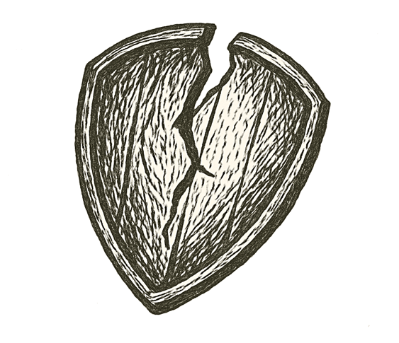
Snow drifted across quiet sidewalks, swirling under streetlights like pale ghosts. Downtown storefronts glowed warm behind frosted glass, shoppers bustling past in winter coats.
A girl’s laughter rang out, bright against the hush of December air.
A car crawled through slush, tires crunching ice. Music thumped from its cabin, bass pulsing like a distant heartbeat.
A shout cracked the night, sharp and ragged. Then a pop — small, metallic, impossibly loud. Footsteps scattered. A scarf fell to the pavement.
Blood bloomed on fresh snow. Silence swallowed the street.
Somewhere above, holiday lights blinked on and off, cold and unfeeling.

How thin is the ice we build our peace upon?

